**Personal Information**

Jeremy Matthews

Colorado State University Global

CSC320 – Programming I

Luis Gonzalez

Due Date: 02/19/2024

**Personal Information**

In our first Critical Thinking Assignment, we are tasked to write our first Java program that prints a person’s First and Last name, their address, city and zipcode on separate lines. In this document you will find the Pseudocode, Source Code, a Screenshot of the program executing, instructions on how I compiled and ran the program, and a link to the Git repository.

**Pseudocode**

Start

Import the Scanner utility

Create the TaxCalculator class

Define the main method

Initialize a Scanner object for user input from console

Prompt the user to enter their income

Read the user's income using the Scanner object

IF income is less than 500

Print "Tax Rate = 10%"

ELSE IF income is at least 500 and less than 1500

Print "Tax Rate = 15%"

ELSE IF income is at least 1500 and less than 2500

Print "Tax Rate = 20%"

ELSE IF income is at least 2500

Print "Tax Rate = 30%"

Close the Scanner object

End

**Source Code**

public class PersonalInformation {  
 public static void main(String[] args) {  
 // Variables to store the fictional person's information  
 String firstName = "John";  
 String lastName = "Doe";  
 String streetAddress = "876 Washington St.";  
 String city = "Denver";  
 String zipCode = "80229";  
  
 // Print each piece of information on a separate line  
 System.*out*.println("First Name: " + firstName);  
 System.*out*.println("Last Name: " + lastName);  
 System.*out*.println("Street Address: " + streetAddress);  
 System.*out*.println("City: " + city);  
 System.*out*.println("Zip Code: " + zipCode);  
 }  
}

**Screenshot**

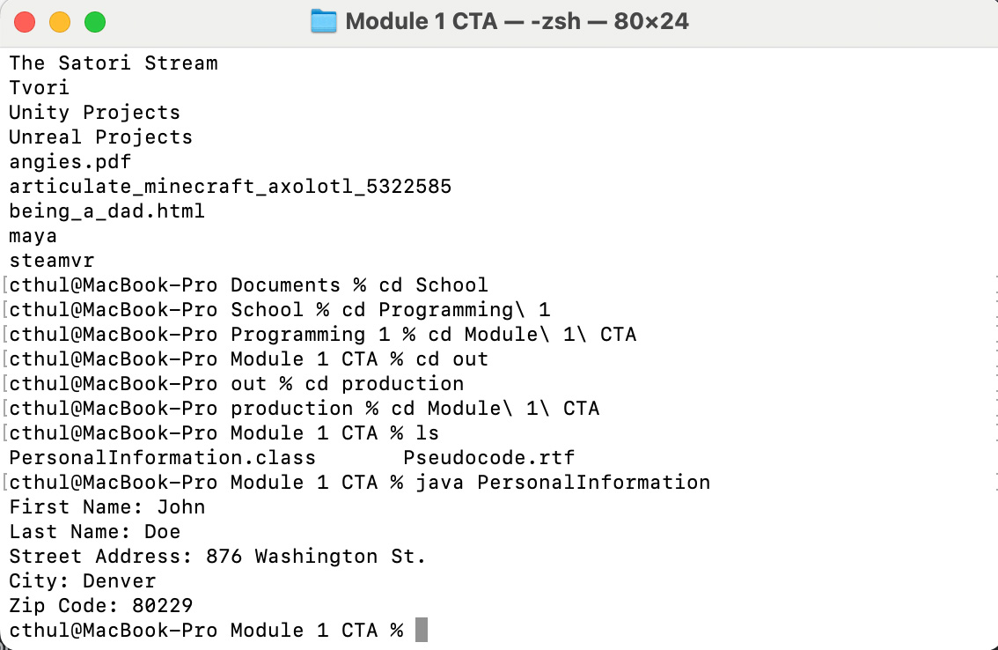

**Compiling and Executing Program**

There are two ways to compile and run a Java program. The first and easiest way to do this is through an IDE. I used the IDE IntelliJ to accomplish this. I wrote the program inside of the editor and saved it, then under the Build menu I chose Build and the IDE compiled and created the PersonalInformation.class file. I can then choose Run under the Run menu and see the program output the personal information for a fictitious person. This can also be accomplished with using the Terminal application on a Mac or Command Prompt on Windows. I’m using a Mac, so I used the Terminal application. First I navigated to the file using the ls command and once in the folder I used the javac followed by PersonalInformation.java. This compliled the java code and output a PersonalInformation.class file. I can then use the java command followed by PersonalInformation to run the program, which resulted in the above screenshot.

**Git Repository Link**

https://github.com/m9dful1/Module_1_CTA